**F. Y. B. Tech Academic Year 2021-22**

**Subject:** Programming and Problem Solving **Trimester:** 2

**Name:** Shreerang Mhatre  **Division:** 11

**Roll No:** 111056  **Batch:** K3

**ASSIGNMENT NO: 8**

**AIM**: Write a C program to swap two numbers using pointers.

**OBJECTIVE:**

**1.** To learn and understand pointers in C .

**2.** To learn and understand concept of call by value and call by reference.

**THEORY:**

**Define Pointer:**

Pointers are variables which hold addresses of other variables. A function can be called either by value or by reference. General syntax of pointer declaration is,

data-type *pointer_name; Data type of a pointer must be same as the data type of a variable to which the pointer variable is pointing.

**Use The Pointer in C:**

A pointer in C is a variable that stores address of another variable. A pointer can also be used to refer to another pointer function. A pointer can be incremented /decremented, i.e., to point to the next/ previous memory location. The purpose of pointer is to save memory space and achieve faster execution time. of pointer in C programming. And also used for-

1. To pass arguments by reference

2. For accessing array elements

3. To return multiple values

4. Dynamic memory allocation

5. To implement data structures

**Concept of call by value and call by reference:**

Arguments can generally be passed to functions in one of the two ways:

**Call by Value:**

sending the values of the arguments - In call by value method, the ‘value’ of each of the actual arguments in the calling function is copied into corresponding formal arguments of the called function. With this method the changes made to the formal arguments in the called function have no effect on the values of actual arguments in the calling function.

**Call by Reference:**

sending the addresses of the arguments - In this method (call by reference) the addresses of actual arguments in the calling function are copied into formal arguments of the called function. This means that using these addresses we would have an access to the actual arguments and hence we would be able to manipulate them

**Implementation:**

**Platform: 64 –**bit Windows 10**.**

**Technology:** Open Source Visual Studio Code

**Algorithm:**

**Step1) Input two numbers from the user and store them in a and b.**

**Step2) Declare three-pointers x,y, and temp.**

**Step3) Set the value in ‘x’ to ‘temp’.**

**Step4) Set the value in ‘y’ to ‘x’.**

**Step5) Set the value in ‘temp’ to ‘x’.**

**Step6) Display the numbers after swapping by using pointers ‘x’ and ‘y’.**

**Flowchart:**

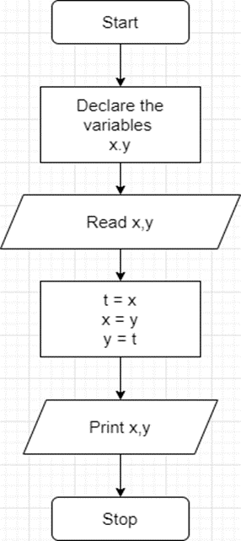

**Visual Studio Code :**

**Code for given program:**

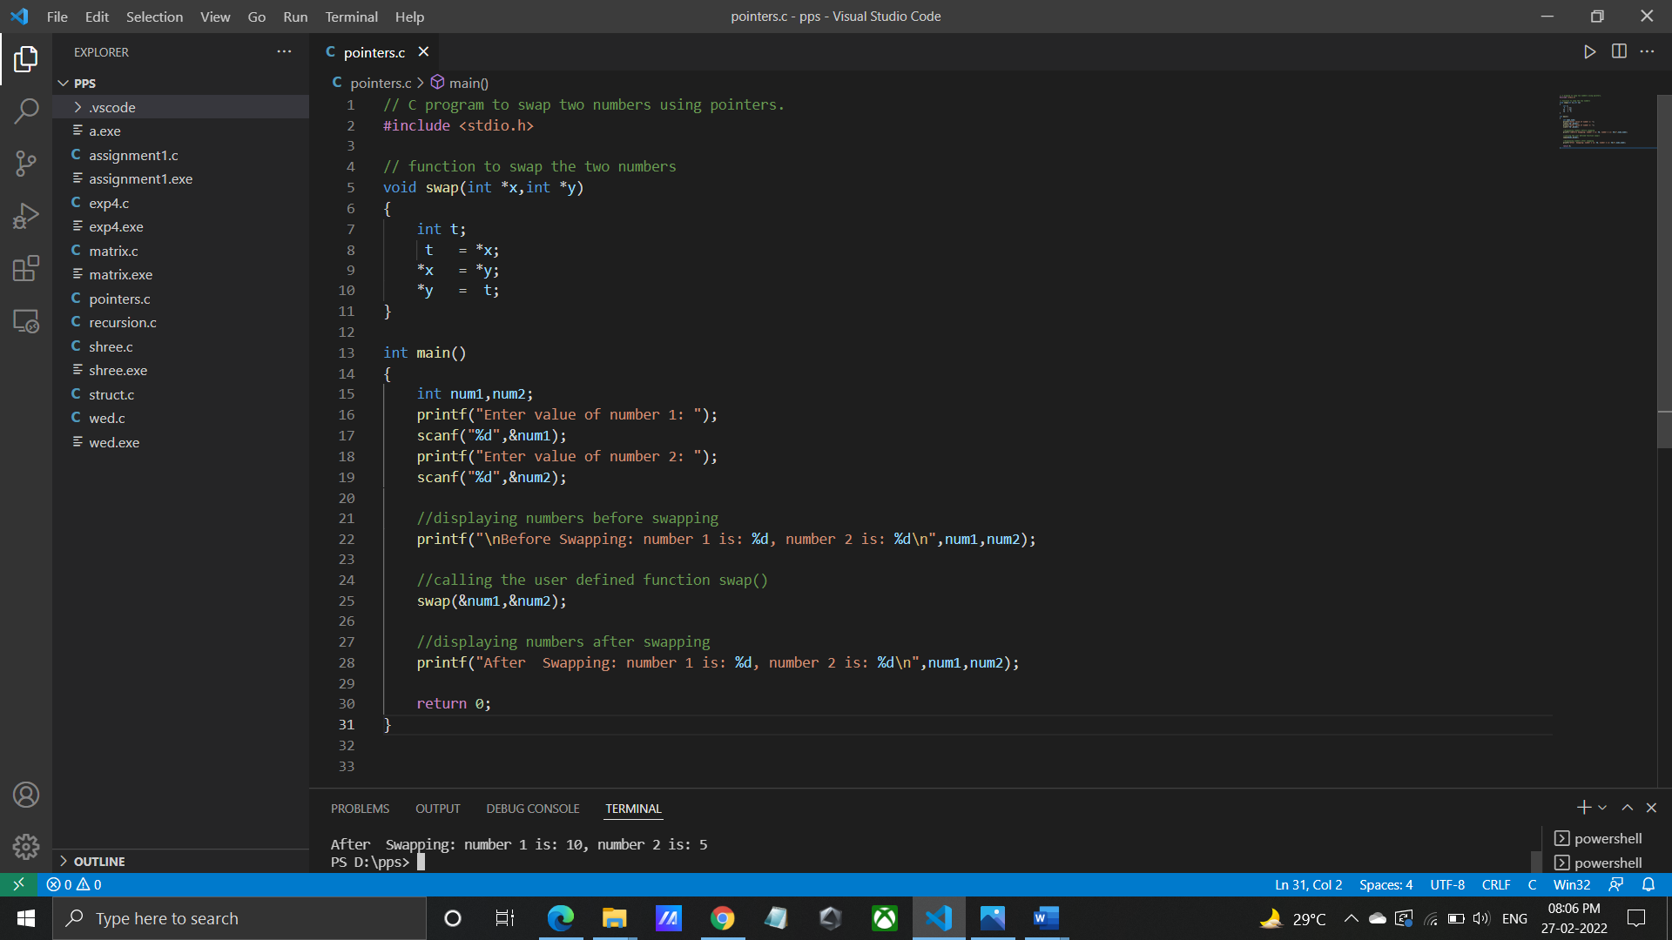

**Output for given program:**

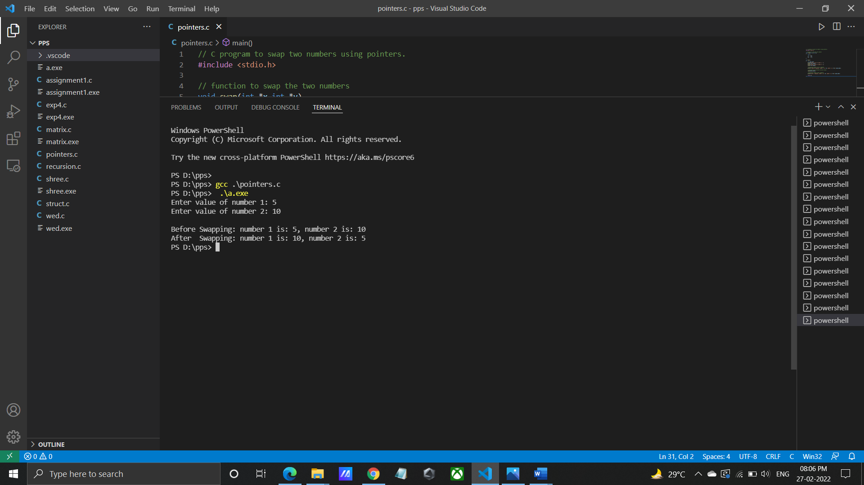

**INPUT:** Enter first matrix elements: 1 4 3 6 7 4 0 8 4

Enter second matrix elements: 2 4 5 9 6 7 0 3 4

**OUTPUT:** Addition of two matrices is:

3 8 8

15 13 11

**Program/ Code:**

// C program to swap two numbers using pointers.

#include <stdio.h>

// function to swap the two numbers

void swap(int *x,int *y)

{

int t;

t = *x;

*x = *y;

*y = t;

}

int main()

{

int num1,num2;

printf("Enter value of number 1: ");

scanf("%d",&num1);

printf("Enter value of number 2: ");

scanf("%d",&num2);

//displaying numbers before swapping

printf("\nBefore Swapping: number 1 is: %d, number 2 is: %d\n",num1,num2);

//calling the user defined function swap()

swap(&num1,&num2);

//displaying numbers after swapping

printf("After Swapping: number 1 is: %d, number 2 is: %d\n",num1,num2);

return 0;

}

**INPUT:** Enter value of number 1: 5

Enter value of number 2: 10

**OUTPUT:** Before Swapping: number 1 is: 5, number 2 is: 10

After Swapping: number 1 is: 10, number 2 is: 5

**CONCLUSION:** Thus implemented the C program to swap two numbers using pointers.

**FAQ:**

1. In C, why is the void pointer useful? When would you use it?

ANS: A void pointer can be really useful if the programmer is not sure about the data type of data inputted by the end user. In such a case the programmer can use a void pointer to point to the location of the unknown data type.

1. What does the error ‘Null Pointer Assignment’ mean and what causes this error?

ANS: A NULL pointer assignment is a runtime error It occurs due to various reasons one is that your program has tried to access an illegal memory location. Illegal location means either the location is in the operating systems address space or in the other processes memory space.